MODUL JNA ( Jaunior Network Administrator )
Jaringan Lokal
- Ether2 IP Address = 192.168.100.1/24

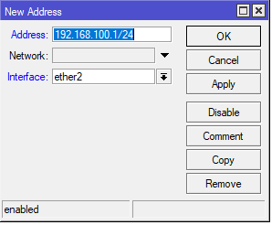

- Buat DHCP Pool Ether2

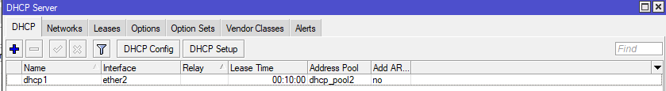

Menagement Bandwitch
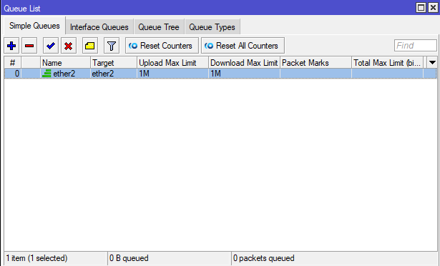
- Ether2 IP Address = 192.168.100.1/24

2. Bandiwtch Upload : 1 MB Download : 1 MB

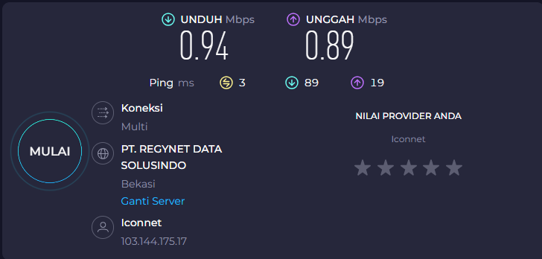

Buat firewall yang memblokir
- Blocking Site = facebook, istagram

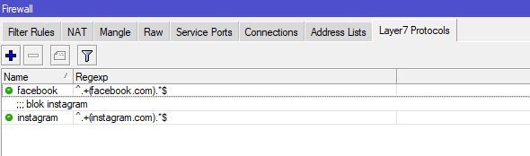

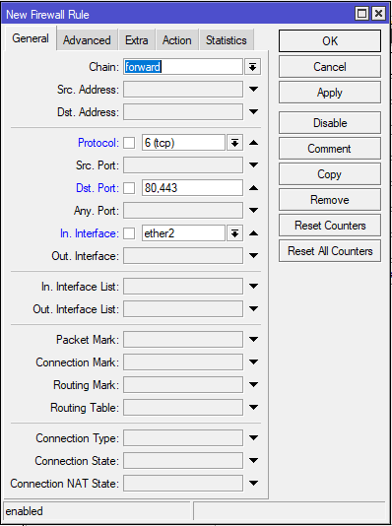
seting filter rules

lalu cek sudah ke blok atau belum

Block instagram
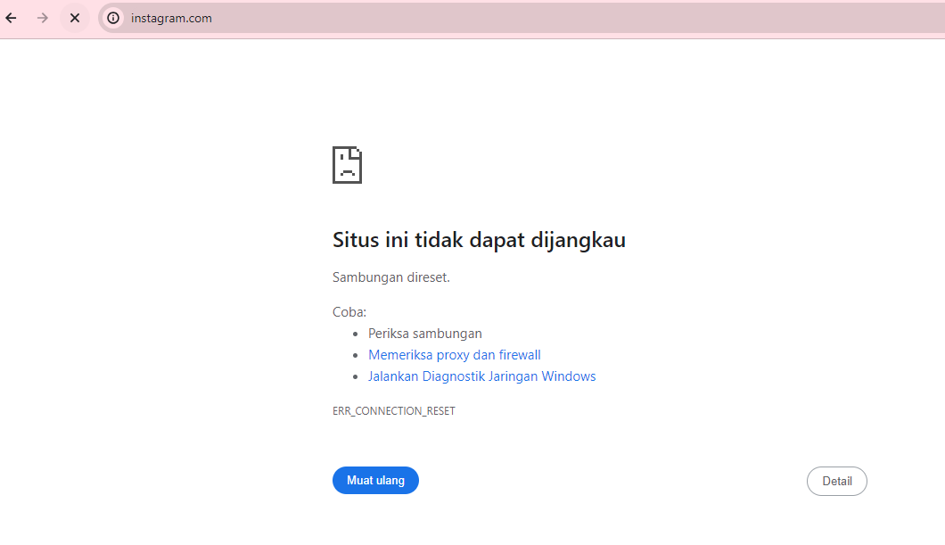

Block facebook

